**ASSESSMENT AND INTERNAL VERIFICATION FRONT SHEET (Individual Criteria)**

|  |  |  |  |  |  |  |  |  |
| --- | --- | --- | --- | --- | --- | --- | --- | --- |
| Course Title | **Advanced Diploma** | | | | **Lecturer Name & Surname** | **NEIL AQUILINA** | | |
| Unit Number & Title | | | **Programming for Computer Games** | | | | | |
| Assignment Number, Title /  Type | | | **Research and Design – Home (24 Hours)** | | | | | |
| Date Set | | | 18/12/2020 | **Deadline Date** | **19/12/2020** | | | |
| Student Name | | Justin Borg | | **ID Number** | 23103L | | **Class / Group** | MSD-4.2B |

|  |  |  |  |  |
| --- | --- | --- | --- | --- |
|  | *Student’s declaration prior to handing-in of assignment:*   * *I certify that the work submitted for this assignment is my own and that I have read and understood the respective Plagiarism Policy* | | | |
|  | ***Student’s declaration on assessment special arrangements (Tick only if applicable)***   * *I certify that adequate support was given to me during the assignment through the Institute and/or the Inclusive Education Unit.* * *I declare that I refused the special support offered by the Institute.* | | | |
| Student Signature: | | Justin.B | **Date :** | 18/12/2020 |

|  |  |  |
| --- | --- | --- |
| Assessment Criteria | Maximum  Mark | Mark  Achieved |
| *KU1: Identify and describe different game engines for different tasks* | 5 |  |
| *KU3: Describe file types for media assets* | 5 |  |
| *KU4: State the relevance of compression settings in media assets* | 5 |  |
| *SE1: Design and specify the details of the game to be developed, including a state machine* | 10 |  |
| Total Mark | 25 |  |

|  |
| --- |
| **Assessor’s feedback to student** |
|  |
| ***(If necessary, use reverse side of page for IV feedback on assignment brief / sample of assessment decisions)*** |

|  |  |  |  |
| --- | --- | --- | --- |
|  | **Name & Surname** | **Signature** | **Date** |
| **Internal Verifier :** Approval of a*ssignment brief* |  | For approval signature, please refer to electronic audit trail |  |
| **Lecturer / Assessor :** Issue of results and feedback to student |  | For approval signature, please refer to electronic audit trail |  |
| **Internal Verifier :** Approval of *assessment decisions (Sample)* |  | For approval signature, please refer to electronic audit trail |  |
| **Learner’s signature upon collection of corrected assignment.** | |  |  |

|  |
| --- |
| Assessment Criteria |
| *KU1: Identify and describe different game engines for different tasks* |
| *KU3: Describe file types for media assets* |
| *KU4: State the relevance of compression settings in media assets* |
| *SE1: Design and specify the details of the game to be developed, including a state machine* |

**Task 1-Game Engines:**

Unreal Engine:

* Unreal Engine mainly makes use of C++ for programming purposes. Unreal Engine also uses Blueprint which is an easier alternative for C++.
* A popular game created on Unreal Engine is Fortnite, which was released in July 2017.
* Unreal Engine is both a 2D and 3D engine.

Unity:

* Unity uses C# for scripting. Scripts are written in a language that Unity can understand and work along with.
* Kerbal Space Program is a widely popular game which was created on Unity in 2011.
* Unity supports both 2D and 3D.

Game Maker:

* Game Maker mainly uses C++ and Pascal for programming its scripts.
* A popular game made on Game Engine is Undertale, which was released in September 2015.
* Game Maker supports both 2D and 3D.

Godot:

* Godot’s main languages that it supports are C, C++, and C#.
* Godot has not produced any big titles as of now but a rather played game produced on Godot is, Kingdoms of the Dump.
* Godot mainly shines in 2D game making but it also supports 3D.

CryEngine:

* CryEngine uses multiple programming languages. These are C++, C#, Flowgraphs visual scripting, Schematyc visual scripting and LUA.
* A very popular game made on CryEngine are the Far Cry titles.
* CryEngine supports both 2D and 3D.

**Task 2-File types for Media Assets:**

1. JPG – Joint Photographic Group is a raster image file. The main upside of using a JPG image format is that it is web-friendly since it compresses the file for it to have a smaller file size. The downside of this is that the image will lose some of its quality due to compression. JPG is mainly used for digital purposes since its not suitable for printing as it loses some of its quality. JPG also does not support transparency.

PNG – Portable Network Graphics are basically the contrary of JPG. This file format typically contains a larger file size than JPG but it keeps its quality. PNG is the preferred option for printing as it has higher quality and also, it supports transparency.

GIF – The Graphics Interchange Format is a bitmap fil format which supports both static and animated images. GIFs use lossless file compressions; therefore, they do not lose any of their quality. Since GIFs are stored using indexed colours, the maximum amount of colours that a GIF file can have is of 256 colors.

1. MP3 – MPEG-1 Audio Layer 3(.mp3), is a standard format for compressing sequences of audio. It is able to compress the audio to a very smaller size than it originally is while still being able to maintain the original audio quality. MP3 files are mainly used for storing audio or a simple press-and-play file since it has a very small file size. When storing music in a CD for example, it is best to use MP3 since CDs do not usually have much storage space.

WAV – A Waveform Audio File(.wav) is a raw audio format which stores audio in segments by using containers. These are lossless and uncompressed which means that they usually have larger file sizes than formats like MP3. Due to their large file sizes, WAV files are not used by many people for common use. They are mainly used in the music industry in order to work with the raw and best quality audio sounds.

**Task 3-Compression in Multimedia:**

1. Whether we are uploading images on a website or on any other platform, it is always a good practice to compress your images. This reduces the size and reduces the amount of time needed for images to be sent or downloaded. There are various ways of compressing images. Vector vs Rasterized, vector images are made up of lines, shapes, and coordinates whilst raster images are made up of pixels, but the main compression difference comes in Lossy vs Lossless. In lossy compression, the file makes a copy of the original image, although not identical this allows for the file to trade between the two images while keeping top-tier quality at a smaller file size. In lossless compression the file size is not as small as a lossy compression would compress it to, but the image result would be a perfect copy of the original, keeping peak quality. In conclusion a lossy compression will give you smaller file sizes and lossless compression will give you better image quality.
2. In audio compression, the bits in the same analogue sound are reduced as much as possible while still producing the same audio and maintaining quality. The most common technique of audio compression is lossy compression, in lossy all non-critical data is removed in order to save more file space. Lossless compression achieves a smaller file size by narrowing the silences in the audio file to almost zero space, while leaving the sound data, untouched.

**LOSSY AUDIO COMPRESSION:**

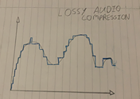

The grey analogue wave represents the original uncompressed audio wave. The lossy compression creates a copy of that wave in a digital wave, this reduces the number of bits being used while still maintaining most of the quality. As seen in the diagram above, the digital wave is still maintaining the same curvature and shape it is simply having to deal with less details and therefore using up less bits.

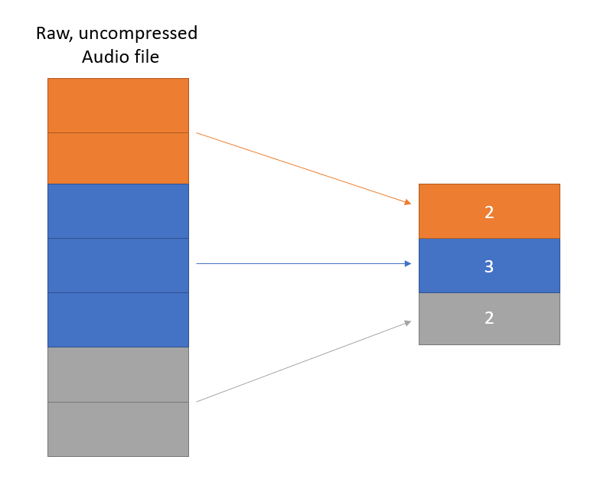In lossless compression, the same audio sections are grouped together. This allows the audio to keep the exact same quality as nothing is being changed or removed whilst still reducing the file size since everything is being grouped.